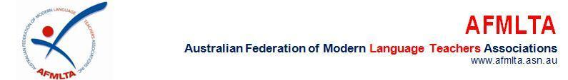

Hon. Erica Stanford
Minister of Education
New Zealand Government
Wellington, Aotearoa New Zealand
17 November 2025
Via email: E.Stanford@ministers.govt.nz and enquiries.national@education.govt.nz
Subject: Concerns Regarding the Proposed Curriculum for Languages
Dear Minister Stanford,
On behalf of the Australian Federation of Modern Language Teachers Associations (AFMLTA), I write to express our deep concern regarding the proposed changes to Aotearoa New Zealand’s national curriculum for languages. The decision to make Te Reo Māori optional diminishes New Zealand’s standing as a leader in supporting indigenous languages. States and territories across Australia are increasingly committed to expanding the teaching of Aboriginal and Torres Strait Islander languages in schools. At the same time, Australia is strengthening language education more broadly, investing in programs that support both Indigenous languages and a wide range of languages other than English.The draft curriculum’s approach to language education is both inequitable and insufficiently ambitious. It encourages—but does not require—schools to offer languages, and proposes minimal instructional time that runs counter to well-established cognitive science research. As New Zealand Association of Language Teachers (NZALT) has highlighted, high-performing education systems do not treat language learning as optional. Regions such as Finland, Singapore, and British Columbia mandate sustained language study because of its proven benefits for literacy, cognitive development, and cultural understanding. In contrast, the New Zealand draft risks widening existing educational disparities and diminishing the vital role languages play in student success.
We strongly encourage the Ministry to revise the curriculum so that it reflects a genuine commitment to equity, inclusion, and excellence. In particular, we endorse NZALT’s recommendations: (1) guaranteeing all students access to Te Reo Māori and NZSL from Years 0–10; (2) requiring students in Years 9–10 to learn an additional language alongside Te Reo Māori or NZSL; and (3) increasing the time and frequency allocated to language learning in line with established learning science. Languages are not optional add-ons—they are central to identity, communication, and global citizenship. We look forward to a curriculum that honours Aotearoa’s unique linguistic heritage and equips all learners for a multilingual future.
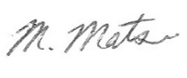
Yours sincerely,
Miyako Matsui
AFMLTA President

